Evaluating and Improving Bankdata’s Cost Forecasts
Case 1 — Forecasting Analysis
DDBD Ruyi Zhong
Data Analytics in Accounting, Spring 2026 · Tools: Excel + Power BI

1. The task and the stakeholder
Bankdata operates the shared IT and operations platform for a group of Danish banks and, each month, produces forecasts of consumption-based costs for the remainder of the year. These forecasts are generated by a statistical model whose output is, in some cases, manually replaced when judged unreliable. The case asks us to analyse selected cost forecasts, evaluate their accuracy, and finally generate a forecast for the following month (December) using the actual data.
The stakeholder is Bankdata’s finance/controlling function, and indirectly the member banks who plan their budgets against these numbers.
Their problems as below:
- They lack a systematic, evidence-based picture of how accurate the forecasts are and where they fail.
- They need a credible December forecast.
Therefore, 3 parts have been included in this project:
- Measure forecast accuracy and diagnose its driver
- Test whether accuracy can be improved with transparent methods
- Produce the December 2025 forecast.
The case explicitly suggests analysing accuracy by cost ID, by financial institute, and across time horizons, analysing how forecasts change as new data arrives (volatility), and analysing cumulative deviation.
The dataset contains 13 cost IDs (e.g. securities held, securities trading, MobilePay and card transactions, logins, reports, archived documents) across 8 anonymized financial institutes (FIs). Actual values run monthly from January 2023 to November 2025; seven forecast vintages were produced at the start of each month from May to November 2025, each covering its own month through December. Values are scaled per institution by a secret multiplier for anonymity, so they are comparable within a series but never across cost IDs or across FIs, every metric we use is therefore percentage-based.

2. Part 1 — How accurate are the forecasts, and why?
Requirement: evaluate forecast accuracy.
We built an error table pairing every forecast with its actual and computed, per point, the absolute percentage error (APE) and the signed percentage error (bias). As the case requires, the mean error uses absolute values (MAPE); the signed mean is reported separately as bias, since it reveals systematic over or under forecasting. We use MAPE rather than R² or raw RMSE because the task is to measure how far forecasts miss, and only a percentage is comparable across series of vastly different magnitudes.

2.1 Accuracy by cost ID
Overall MAPE is 9.9% with a small under-forecast bias of −2.0%, but the average hides a very wide spread:
Cost ID | Name | MAPE | Bias | Reading
150 | Securities held | 0.8% | −0.3% | Near-perfect — stable stock variable
9683 | Logins | 4.7% | −2.1% | Easy — smooth behavioral series
9657 | Card transactions | 5.2% | −1.2% | Easy
9700 | Domestic transactions | 5.2% | −2.2% | Easy
9656 | MobilePay | 6.4% | −1.8% | Easy
9649 | Credit cases | 10.4% | −6.0% | Harder; under-forecast
9692 | Documents archived | 11.5% | +5.5% | Lumpy; over-forecast
9652 | Reports | 12.4% | +1.7% | Lumpy / event-driven
9768 | Dopix documents | 16.5% | +1.9% | Lumpy / event-driven
360 | Domestic securities trading | 21.3% | −2.9% | Volatile but unbiased
2370 | Foreign securities trading | 21.7% | −16.2% | Volatile AND systematically low

2.2 Accuracy by financial institute
Across banks, MAPE ranges only from 8.2% to 12.1. Thus, Institute-level effects are minor; effort should target cost types, not banks.

2.3 Horizon, vintage, and a hidden effect (the key analytical finding)
Pooled across all months, MAPE looks essentially flat across forecast horizons. Taken alone this suggests the model does not benefit from incoming data. However, this is an aggregation artefact: short horizons are dominated by the hard summer months, long horizons by the easier autumn months, and the two effects cancel.
Controlling for this with a cross-check matrix , target month on the rows, forecast-creation month (vintage) on the columns, reverses the conclusion. The November target falls from 11.5% (May vintage) to 7.1% (November vintage), and October shows the same pattern. So fresh data genuinely does help.
In addition, the summer target months (May–July) remain the hardest (12–13%) across every horizons.

2.4 Forecast volatility (stability)
The case also asks how forecasts change as new data arrives. We measured the revision spread, (max−min)/average of the successive vintage forecasts for a fixed target month, on representative series. Securities held (150) is revised by only ~2% across vintages; foreign securities (2370) by around 21%.
Thus, stability mirrors accuracy, the model "changes its mind" most about exactly the series it forecasts worst, such as ID 2370. Importantly, 360 is equally volatile but non-directional, confirming that high volatility does not imply bias.

2.5 Cumulative deviation
Finally, we examined cumulative (running-total) deviation, which matters for annual budgeting because monthly errors either compound or cancel in a total.
For foreign securities (2370), the May-vintage cumulative deviation drifts from +10% early in the year to −5% by Novembe, thus the autumn under-forecasting outweighs the summer over-forecasting, so even the full-period total ends meaningfully off. This reframes the stakeholder’s risk: a single early forecast round can mis-state the annual cost by 5%+ even for series that look acceptable month-to-month, so later vintages give a more reliable annual figure.

3. Part 2 — Can accuracy be improved?
Requirements (implied by the case’s emphasis on improving and generating forecasts): test transparent alternatives to the existing model.
We did not use regression or machine-learning regressors (Lasso, neural networks, etc.). Because the data is univariate (only each series’ own history, no external predictors), short (~35 monthly observations), seasonal, and must be delivered in Excel/Power BI. Instead we built two additional candidates and ran a head-to-head selection.
- Seasonal-naive-with-drift (SND): last year’s same month × the average recent year-over-year growth (the three months known at forecast time). It captures seasonality and trend with no fitted parameters, and it directly uses the recent data the model under-exploits.
- Bias-adjusted model: the Bankdata forecast × a correction factor estimated only from the early (May–Aug) window, to remove a systematic offset, aimed at the directionally-biased series.(such as ID 2370)
We then chose the best of current Model, SND, Bias-adjusted per cost ID using only the May–Aug data and validated the choice out-of-sample on Sep–Nov data. This train/test split is what makes the improvement claim honest rather than hindsight.
We note one limitation: the two windows differ in difficulty (summer is harder), so the absolute MAPE levels in the test window are optimistic; however, the period difficulty applies equally to all methods, so the method ranking is unaffected.
Results of the validated selection (out-of-sample, Sep–Nov vintages):
ID | ID name | Model | SND | Bias-adj | Winner
150 | Securities | 0,72% | 1,36% | 0,59% | Bias djust based on model
360 | Domestic Securities | 16,79% | 22,85% | 16,84% | Model
2370 | Foreign Securities | 19,74% | 24,85% | 11,79% | Bias djust based on model
9649 | Credit cases | 10,79% | 9,94% | 8,30% | Bias djust based on model
9652 | Reports | 9,30% | 20,00% | 9,60% | Model
9656 | MobilePay transactions | 5,43% | 2,76% | 5,37% | SND
9657 | Card transactions | 3,86% | 2,56% | 4,47% | SND
9683 | Logins Mobilbank/Netbank | 3,15% | 2,12% | 2,49% | SND
9692 | Documents archived | 6,85% | 15,69% | 9,56% | Model
9700 | Domestic transactions | 4,47% | 2,06% | 3,25% | SND
9701 | International transactions | 7,24% | 4,04% | 7,13% | SND
9702 | European transactions | 5,63% | 4,93% | 5,73% | SND
9768 | Dopix documents | 10,58% | 19,38% | 10,08% | Bias djust based on model

SND wins on the stable behavioral series (MobilePay, cards, logins, domestic/international/European transactions). These have strong, consistent seasonal and trend structure, so a simple history projection beats the model.
The model (or its bias-adjusted version) wins on the volatile and lumpy series (securities trading, reports, archived documents, Dopix), whose history does not cleanly predict their future.
Crucially, the bias-adjusted model is the clear winner for foreign securities (2370). Bias correction was applied only where the bias is large and persistent.

4. Part 3 — The December 2025 forecast
Requirement: generate the December forecast from the actual data. For each of the 104 cost-ID × FI series we computed all three candidate December forecasts and routed each series to its validated winning method:
- SND for the behavioural series (9656, 9657, 9683, 9700, 9701, 9702).
- Bias-adjusted model for the systematically biased series (2370, 9649, and marginally 150, 9768).
- Plain Bankdata model for the volatile/lumpy series where it already wins (360, 9652, 9692).
The recommended December forecast equals each series’ December value from its assigned method, and a "deviation vs Bankdata" column shows where and by how much we depart from Bankdata’s own number. For most series the deviation is zero (we trust the model where it is best); the deliberate, justified changes concentrate in the behavioural series (where SND wins) and in foreign securities (raised +7% by the bias correction). Because December has no actual yet, its accuracy cannot be checked now.

4.1 Delivery in Power BI
The whole pipeline is exposed in an interactive Power BI report connected live to the analysis workbook.
A Forecast Explorer page lets a manager select a cost ID and FI and instantly see the chosen method, the recommended forecast, the deviation from Bankdata, and a line chart of actual (2023–2025) against the competing forecasts.
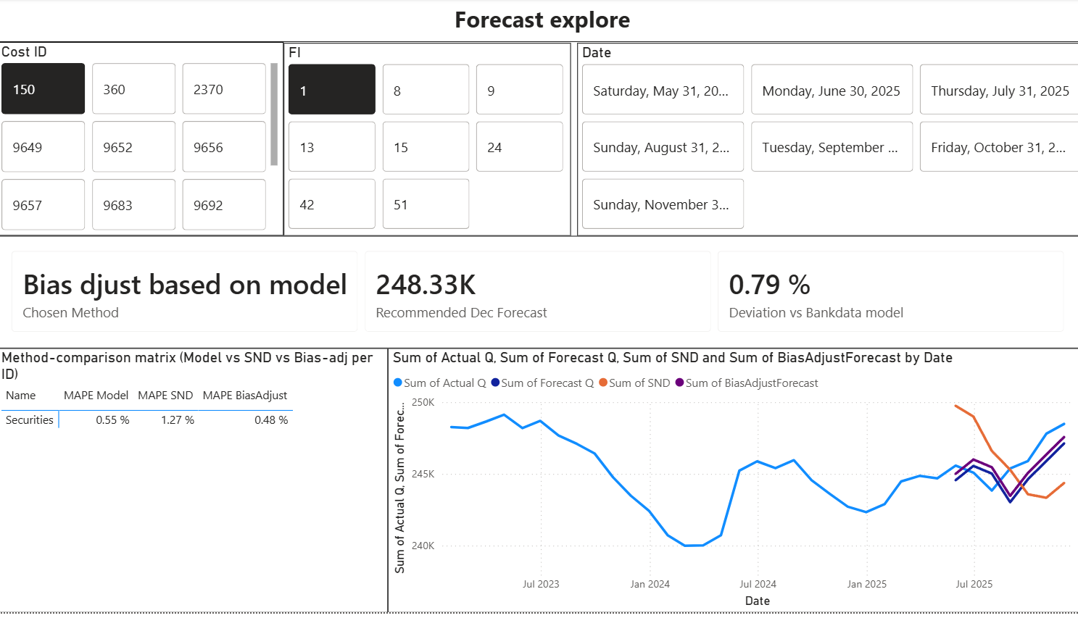
A Manual-override page provides a bounded (±20%) adjustment slider so a manager can apply business judgement on top of the data-driven number. This override is intended specifically for the event-driven series (reports, Dopix, archived documents), where one-off events a human can foresee, but the model cannot.
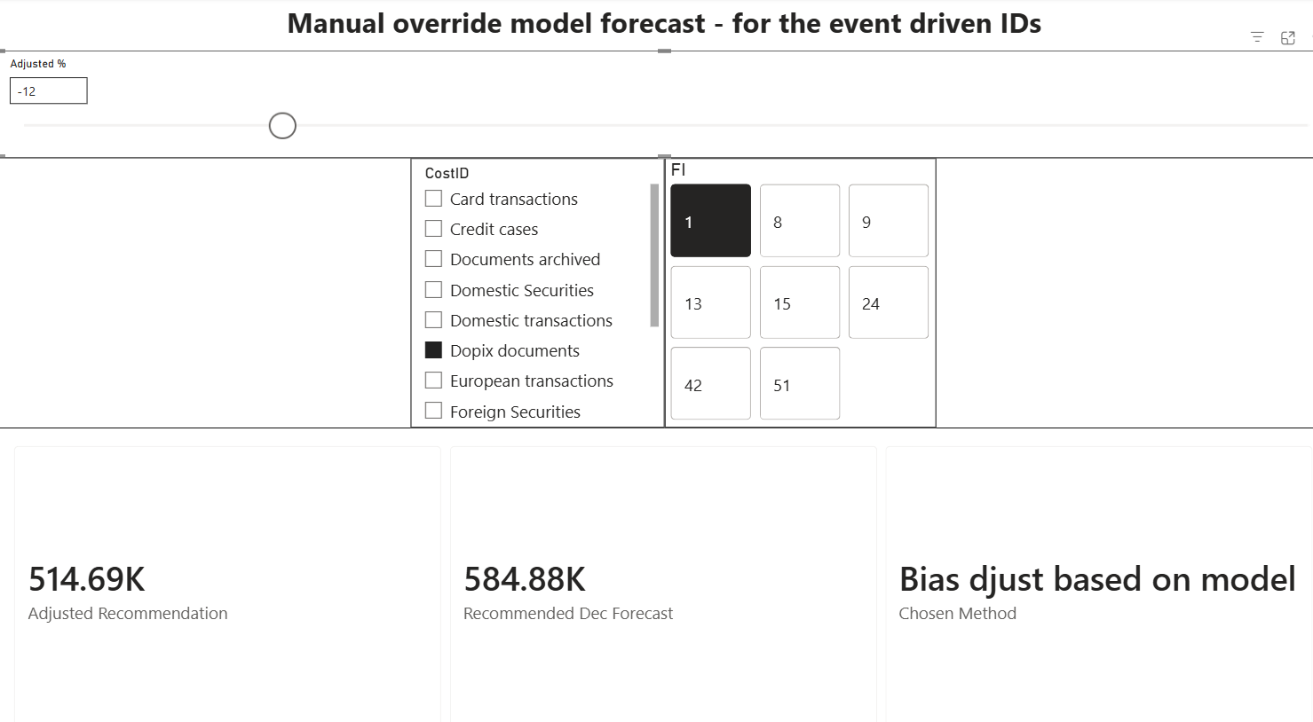
An Accuracy page reproduces the accuracy-by-ID, accuracy-by-FI, MAPE-by-horizon and cross-check views interactively.
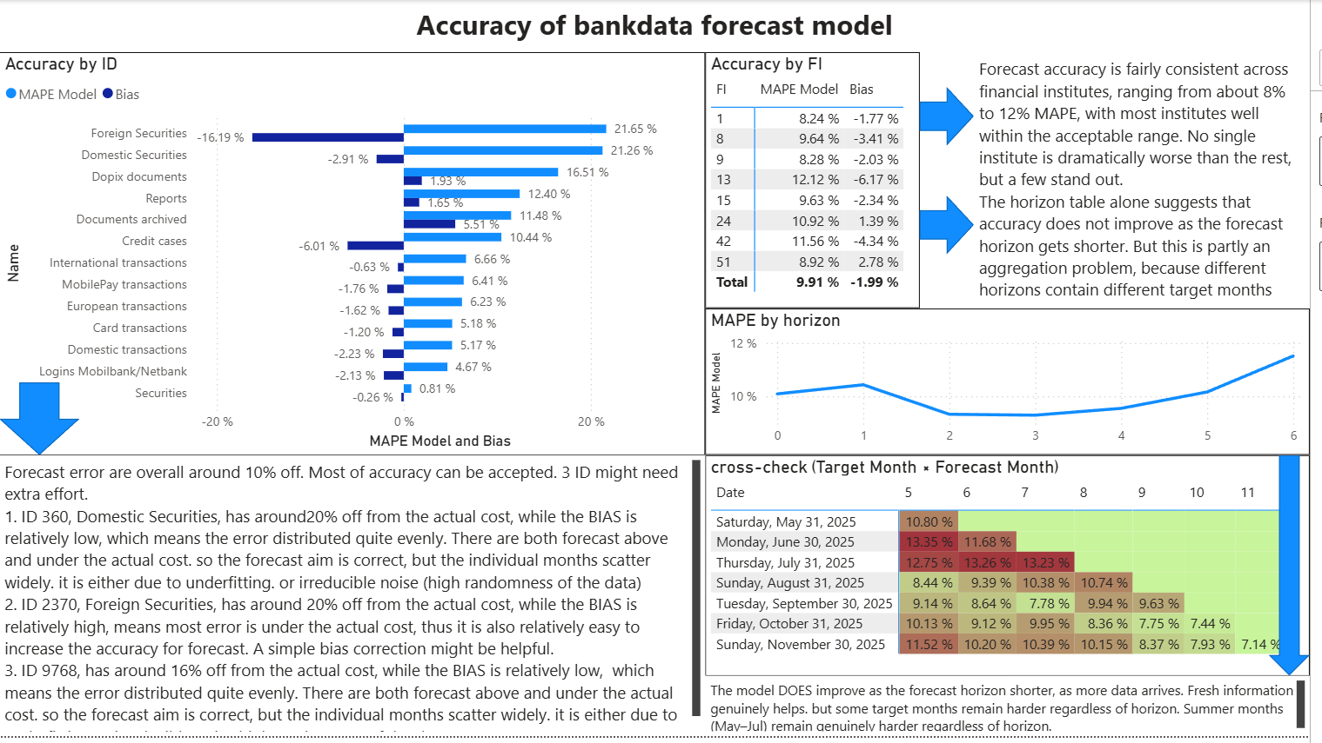

5. Conclusion and actionable insights
Bankdata’s forecasts are good on average (9.9% MAPE) but highly uneven, and the analysis points to concrete and prioritised actions:
- Correct the systematic bias in foreign securities (2370). A persistent −16% under-forecast is a not noise. The validated bias-adjusted method already cuts its error by roughly a third and should be adopted for this series, with the correction factor re-estimated periodically rather than fixed.
- Adopt the ID related method selection. Different cost types have different dynamics; a single model leaves accuracy on the table. Using the simple seasonal method on the behavioural series and the model on the volatile ones cuts out-of-sample MAPE from 8.0% to 6.8% with fully transparent, auditable logic.
- Make the model learn within the year. The cross-check shows fresh data does help; blending in a recent-growth term (as SND does) is a cheap way to inject information the current model under-uses, especially for the behavioural series.
- Make manual overrides explicit and targeted. Replace invisible manual replacements with the bounded, documented slider, reserved for the event-driven series (reports, Dopix, archiving) where human knowledge of upcoming events genuinely beats the model.

5.1 Issues not fully resolved, and where to go next
- Seasonal difficulty remains unsolved. Summer target months (May–July) are genuinely harder (12–13% MAPE). This is a real seasonal effect we identified but did not fix; it would need either richer seasonal modelling or simply accepting wider forecast intervals for those months.
- Volatile but unbiased series (e.g. domestic securities 360) cannot be fixed by bias correction. Reducing their error would require new explanatory information rather than a better projection of their own history.
- External variables might be add extra explanation for forecasting. Our common-shock analysis showed payment-series errors are 85–92% synchronised across banks (a shared activity driver), while securities-series errors are only ~50% common and credit/report errors are largely idiosyncratic. This suggests: a consumption/activity indicator (e.g. retail-sales or card-turnover statistics) as a regressor for the payment series, and the Danish policy rate (freely available via the Nationalbank statbank API, table DNRENTM) for the securities-trading series, because the rate is a plausible driver of trading activity. These should be tested with a single, simple regression each (the data is too small for complex models).

